**DAILY ONLINE ACTIVITIES SUMMARY**

|  |  |  |  |  |  |  |  |  |
| --- | --- | --- | --- | --- | --- | --- | --- | --- |
| **Date:** | **24/05/2020** | | | | | **Name:** | **Shone K Sunny** | |
| **Sem & Sec** | **8th & A sec** | | | | | **USN:** | **4AL14CS081** | |
| **Online Test Summary** | | | | | | | | |
| **Subject** | | **No Test conducted** | | | | | | |
| **Max. Marks** | | **----** | | **Score** | | | **----** | |
| **Certification Course Summary** | | | | | | | | |
| **Course** | **Advanced Network Security on AWS** | | | | | | | |
| **Certificate Provider** | | | **Pluralsight** | | **Duration** | | | **1 hr 35 mnts** |
| **Coding Challenges** | | | | | | | | |
| **Problem Statement:Find factorial of a number using BigInteger** | | | | | | | | |
| **Status:solved** | | | | | | | | |
| **Uploaded the report in Github** | | | | | **Yes** | | | |
| **If yes Repository name** | | | | | **shonekks** | | | |
| **Uploaded the report in slack** | | | | | **Yes** | | | |

Certification Course Details: (Attach the snapshot and briefly write the report for the same)

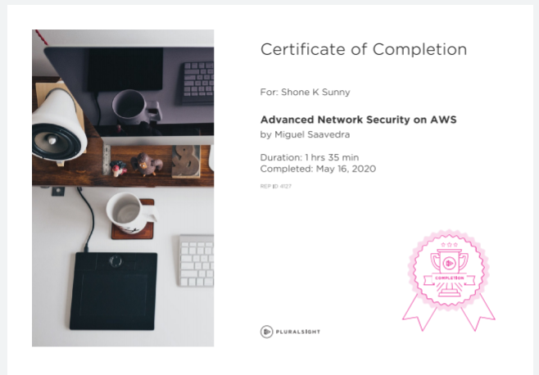

In this course we will cover all of the major areas of AWS networking and associated services you'll need to know to become an AWS networking specialist and obtain the certification, including:

* Refresh core networking - IPv4, VLANS, DNS, BGP and the 7-Layer OSI Model.
* Plan and Implement pure-cloud AWS Networks.Design and Implement Complex and Scalable Hybrid networks.
* Plan and Implement appropriate Network Security Controls.
* Integrate AWS Advanced network services with your applications.Design and Implement compliant networks.
* Advanced Operational and Troubleshooting Skills & Techniques.
* Network automation skills & Techniques

Coding Challenges Details: (Attach the snapshot and briefly write the report for the same)

